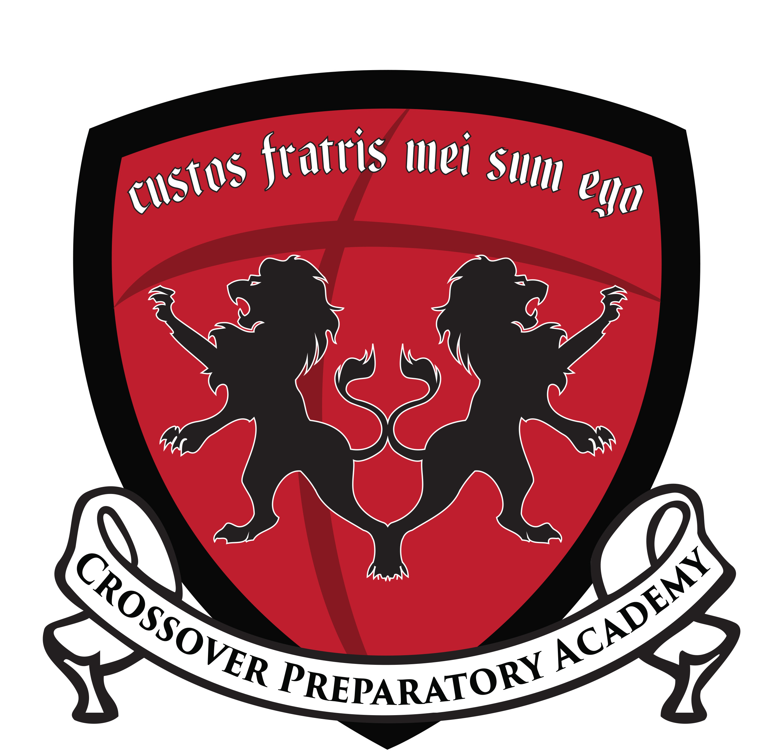
Wellness Policy Statements

Crossover Preparatory Academy, a non-profit LLC of Crossover Community Impact, Inc., (CPA) is committed to partnering with young men to fulfill their God-given potential in mind, body, and spirit.

To that end, all students in CPA shall possess the knowledge and skills necessary to make nutritious food choices and remain physically active throughout life.

To meet these commitments, CPA adopts this school wellness policy with the following commitments to nutrition, physical activity, comprehensive health education, marketing, and implementation. The intent of this policy is to effectively utilize school and community resources and to equitably serve the needs and interests of all students and staff, taking into consideration differences in culture.

Nutrition Education:

CPA will strive to achieve the following goals:

- Ensure that all students receive a foundation in 7th and 8th in both knowledge and practice of healthy eating:
  - 7th Grade Projects
    - Make a poster over one of the 5 food groups and present to class
    - Prepare a healthy meal for the family (including a carbohydrate, a vegetable, and a protein)
  - 8th Grade Projects
    - Record two weeks of eating in a composition notebook (breakfast, lunch, dinner, snacks, must include calories and macronutrients)
    - Prepare a health meal for family (meal must have a carbohydrate, vegetable, and a protein)
    - Prepare a healthy lunch for yourself (meal must have a carbohydrate, vegetable, and a protein)
- Conduct nutrition education activities and promotions that involve students, parents, and the community.
  - Students will prepare and cook a healthy meal for their family or friends (must have video or pictures for proof)
  - Students will visit a neighborhood or community garden and learn basics of gardening
- Improve the cafeteria environment so that it promotes health and nutrition education. Posters may include information over topics such as:
  - Food Pyramid / MyPlate
  - Farming
  - Hydration
  - Sugar
- Provide training and education for faculty and staff to promote wellness and to educate student in making health lifestyle choices.
  - Faculty and staff will be provided with newsletters and emails throughout the year.
  - Faculty and staff will be encouraged to display healthier eating habits in front of the kids.

Nutrition Promotion

CPA will strive to achieve the following goals:

- Provide positive, motivating messages, both verbal and non-verbal, about healthy lifestyle practices throughout the school setting. All school personnel will help reinforce these positive messages.
  - Nutritional posters around school (faculty and staff will be encouraged by P.E teacher to read nutrition posters and to verbally encourage students to read posters as well)
  - Posters about anorexia and malnutrition will be posted around the school
- Involve students in planning for a healthy school environment. Students will be asked for input and feedback, and attention will be given to their comments.
  - Students will be given a survey by P.E teacher twice a year to discuss nutrition options for their school (e.g., What should we add to menu? How can we do better as a school in promoting about nutrition? As a student, what could you do better to promote a healthier environment?)
- Promote healthful eating, physical activity, and healthy lifestyles to students, parents, teachers, administrators, and the community at school events (e.g., school registration, parent-teacher conferences, PTA meetings, open houses, health fairs, teacher in-services, and other events).
  - P.E teacher will have a profile on each student that participates in gym, the endurance and strength of each student will be documented either daily or weekly. Parents will receive their son’s report as part of the trimesterly report card.
  - Parents will be informed of and encouraged to attend different fitness activities around the city. They will be given newsletters with information about health fairs, yoga, boxing, running, weightlifting classes, etc.

Physical Activity

CPA will strive to achieve the following goals:

- Physical Activity Requirements
  - Morning P.E is required for all 7th-8th graders each trimester.
  - 8th graders must complete a Wilderness Survival course during May Term.
  - 9th graders must take one trimester of PE.
- Pass fitness tests at the end of the year
  - 1 mile test
  - Pushup test (20 perfect pushups)
  - Squat test (25 perfect squats)
  - Pull up test (reps are counted from a dead hang)
  - Agility test (L cone and 5-10-5 test)
- Recess and extracurricular
  - Students will have recesses and free sport available during Advisory period on at least a weekly basis.
  - Students will be able to participate in a sport after school.

Other School Based Activities

CPA will strive to achieve the following goals:

- Promote physical and nutrition education in after-school programs
- Promote health and nutrition in other school-based activities (such as school events, field trips, dances, assemblies, fundraisers, and sports events).
- Promote health and wellness by hosting health fairs, theme weeks, and guest speakers promoting a healthy lifestyle.

Nutrition Guidelines for All Foods on Campus

CPA will:

Offer school meal menus (lunch, breakfast, and snack) that meet the meal patterns and nutrition standards established by the U.S. Department of Agriculture and the Oklahoma Department of Human Services, School Nutrition Program

Follow the USDA Smart Snacks in School Standards for all foods sold in school.

There are currently no standards placed on food items given (not sold) to students. The wellness committee may adopt more stringent standards on all foods available to students at a later date.

Food and Beverage Marketing of Foods Sold on Campus

The administration will ensure only foods meeting the Smart Snack standards will be marketed during the school day. Marketing of non-compliant food and beverages will not be permitted during the school day.

Implementation and Review

- Isaac Bennett, Athletic Director is responsible for insuring the implementation of the school wellness policy as written, here.
- The school wellness policy will be reviewed on an annual basis by the Safe and Healthy Advisory Committee (“Crossover Advisory Board”), which will compare CPA’s policy to the model policy (the model local wellness policy can be found online here: https://www.healthiergeneration.org/_asset/wtqdwu/14-6372_ModelWellnessPolicy.do+++++c). The Athletic Director, as a member of that committee, will report on the evaluation of the policy and progress toward goals.
- Links to the current policy and the most recent progress report are to be posted, at all times, on the school website, www.crossoverprep.org. A copy of the policy and implementation report will be made available to all who request it. Anyone interested in participating in the implementation and ongoing development of the wellness policy is encouraged to email Isaac Bennett at isaac.bennett@crossoverprep.org

Crossover Advisory Board Membership:

Chair: Philip Abode, Executive Director of Crossover Preparatory Academy and Senior Pastor of Crossover Bible Church
Members:
John Lepine Sr., Ph.D., Principal of Crossover Preparatory Academy
Kelly Stocksen, Teacher at Crossover Preparatory Academy
London Malveaux, Administrative Assistant at Crossover Preparatory Academy andpParent of Crossover Preparatory Academy student
Michael Finley, retired pastor and senior citizen
Jordan Ware, Ph.D., education researcher
Linda Shrewsbury, educator and senior citizen
David Paige, Ph.D., educator
Henry Smith, banker (business community representative)
Louise Whitley, nurse (nonprofit health organization)
Mark Reisner, educator
Nate Madden, educator
Kevin McIlwain, educator, law student
Rebekah McIlwain, educator
Law enforcement?

